

A SMART KIT APPROACH FOR
VISUALLY IMPAIRED PEOPLE

Submitted by

AKSHAYA SANTHOSH (810421243005)
LIMA C J (810421243025)
MALAVIKA M A (810421243028)

Of

DHANALAKSHMI SRINIVASAN ENGINEERING COLLEGE(AUTONOMOUS)
PERAMBALUR – 621 212

A PROJECT REPORT

Submitted to the

FACULTY OF INFORMATION AND COMMUNICATION ENGINEERING

In partial fulfilment of the requirements
for the award of the degree
Of
BACHELOR OF TECHNOLOGY
In
ARTIFICIAL INTELLIGENCE AND DATA SCIENCE

ANNA UNIVERSITY CHENNAI - 600 025
MAY 2025

BONAFIDE CERTIFICATE

Certified that this project report titled “A SMART KIT APPROACH FOR VISUALLY IMPAIRED PEOPLE” is the Bonafide work of “AKSHAYA SANTHOSH (810421243005), LIMA C.J(810421243025), MALAVIKA M.A (810421243028)” who carried out the research under my supervision. Certified further, that to the best of my knowledge the work reported here in does not form part of any other project report or dissertation on the basis of which a degree or award was conferred on an earlier occasion on this or any other candidate.

SUPERVISOR  Mr SARAVANAN S, M Tech, MBA, (PhD)  Assistant Professor,  Department of Artificial Intelligence and Data Science  Dhanalakshmi Srinivasan Engineering College (Autonomous)  Perambalur- 621 212 | HEAD OF THE DEPARTMENT  Dr SHREE K.V.M, M.E, PhD.,  Professor & Head,  Department of Artificial Intelligence and Data Science  Dhanalakshmi Srinivasan Engineering College (Autonomous)  Perambalur- 621 212

Submitted to Project Viva-Voce Examination held on------------------

INTERNAL EXAMINER EXTERNAL EXAMINER

ACKNOWLEDGEMENT

It is with immense pleasure that I present my first venture in the field of real applications of computing in the form of project work. First, I am indebted to the Almighty for his choicest blessing showered on me in completing this endeavour.
I express my sincere thanks to Shri. A. SRINIVASAN, Chancellor, Dhanalakshmi Srinivasan University, for having given me an opportunity to study in this Institution.
I would also like to acknowledge Dr. D. Shanmugasundaram, M.E., Ph.D., F.I.E., C.Eng, Principal Dr. K. ANBARASAN, M.E, Ph.D., Dean Dhanalakshmi Srinivasan Engineering College (Autonomous), Perambalur for their moral support and encouragement they have rendered throughout the course. I express my sincere thanks to the Head of the Department Dr. SHREE K.V.M, M.E, Ph.D., for having provided us with all the necessary specifications.
I owe my heartfelt thanks to my Internal Guide Mr. SARAVANAN S for his guidance and suggestions during this project work.
We render our thanks to all the staff members and programmers of department of ARTIFICIAL INTELIGENCE AND DATA SCIENCE for their timely assistance.

ABSTRACT

This presents a smart assistive system embedded in a kit to enhance mobility and navigation for visually impaired individuals. The system integrates five ultrasonic sensors, a web camera, and a GPS receiver to deliver real-time obstacle detection and guidance, while machine learning algorithms enable reliable path identification to support journey planning and tracking. Multimodal feedback through voice prompts, audio tones, and vibration cues provides users with enhanced environmental awareness and promotes safer, more independent navigation. Tested with ten visually impaired participants, the system demonstrated improved mobility performance compared to traditional white cane usage. Usability evaluations showed that 80% of users found the system beneficial, and 60% experienced a reduction in cognitive effort during navigation, indicating that it supports both physical movement and mental ease. Despite these positive results, challenges such as improving global navigation accuracy and reducing hardware size remain. Future enhancements will focus on refining navigation algorithms and miniaturizing components to improve comfort and overall usability. Overall, the proposed system offers a promising solution to increase mobility, confidence, and independence for visually impaired individuals in everyday environments.

TABLE OF CONTENTS

CHAPTER NO. | TITLE | PAGE NO.
 | ABSTRACT | iv
 | LIST OF FIGURES | vii
 | LIST OF ABBREVIATIONS | ix
1 | INTRODUCTION
 | - INTRODUCTION  - PURPOSE  - PROBLEM STATEMENT  - MOTIVATION  - OBJECTIVES | 1  2  3  3  4
2 | LITERATURE SURVEY | 5
3 | SYSTEM ANAYSIS  - EXISTING SYSTEM  3.1.1 DISADVANTAGES  - PROPOSED SYSTEM  3.2.1 ADVANTAGES | 14  15  15  15
4 | SYSTEM REQUIREMENTS  - HARDWARE REQUIREMENTS  - SOFTWARE REQUIREMENTS | 16  16
5 | SYSTEM IMPLEMENTATION  - LIST OF MODULES  - MODULE DESCRIPTION  5.2.1 OBSTACLE DETECTION MODULE  5.2.2 GPS NAVIGATION MODULE  5.2.3 VOICE RECOGNITION MODULE  5.2.4 CAMERA BASED SCENE RECOGNITION MODULE  5.2.5 EMERGENCY ALERT MODULE | 17  17  17  18  18  19  20
6 | SYSTEM DESIGN  - SYSTEM ARCHITECTURE  - UML DIAGRAM  6.2.1 USE CASE DIAGRAM  6.2.2 SEQUENCE DIAGRAM  - ACTIVITY DIAGRAM | 21  22  22  23  24
7 | HARDWARE DESCRIPTION  - OVERVIEW  7.1.1 FEATURE  7.1.2 COMPONENTS  7.1.3 FUNCTIONS  7.1.4 LIBRARIES  7.1.5 IoT & EMBEDDED SYSTEM FRAMEWORK  - ARCHITECTURE  7.2.1 ANATOMY  7.2.2 KEY TECHNOLOGIES USED  7.2.3 INTERNET OF THINGS  - ARCHITUCTURE OF JSP  7.3.1 ADVANTAGES OF IoT  7.3.2 ARDUINO  7.3.3 RUN TIME ENVIRONMENT  7.3.4 IoT LIFE CYCLE | 25  26  27  27  27  28  29  29  31  31  32  32  33  34  35
8 | TESTING  - AIM OF TESTING  - TEST CASE  - TYPES OF TESTING  8.3.1 WHITEBOX TESTING  8.3.2 BLACKBOX TESTING  8.3.3 UNIT TESTING  8.3.4 FUNCTIONAL TESTING  8.3.5 PERFORMANCE TESTING  8.3.6 INTEGRATION TESTING  8.3.7 VERIFICATION AND VALIDATION  8.3.8 SYSTEM TESTING  8.3.9 STRUCTURE TESTING  8.3.10 OUTPUT TESTING  8.3.11 USER ACCEPTANCE TESTING | 37  37  37  38  40  41  41  42  43  44  45  45  45  46
9 | CONCLUSION AND FUTURE ENHANCEMENT  9.1 CONCLUSION  9.2 FUTURE ENHANCEMENT | 47  47
 | APPENDICES  - SAMPLE CODE  - SCREENSHOTS | 48  52
 | REFERENCES | 56

LIST OF FIGURES

FIGURE NO. | TITLE | PAGE NO.
6.1 | System Architecture | 21
6.2.1 | Use Case Diagram | 22
6.2.2 | Sequence Diagram | 23
6.4 | Activity Diagram | 24
7.2 | Android Architecture | 30
7.3 | Architecture of JSP | 33

LIST OF ABBREVIATIONS

 | WHO |  |  | - | WORLD HEALTH ORGANIZATION
 | PS |  |  | - | PATH SAARATHI
 | ETA |  |  | - | ELECTRONIC TRAVEL AID
 | GPS |  |  | - | GLOBAL POSITIONING SYSTEM
 | OCR |  |  | - | OPTICAL CHARACTER RECOGNITION
 | TTS |  |  | - | TEXT TO SPEECH
 | IMU |  |  | - | INERTIAL MEASUREMENT UNIT
 | RGB-D |  |  | - | RED GREEN BLUE AND DEPTH
 | CNN |  |  | - | CONVOLUTIONAL NEURAL NETWORK
 | PD |  |  | - | PATH DETECTION
 | DEP |  |  | - | DEPTH PERCEPTION
 | NAV |  |  | - | NAVIGATION
 | ARM |  |  | - | ADVANCED RISC MACHINE
 | GIS |  |  | - | GEOGRAPHIC INFORMATION SYSTEM
 | PIL |  |  | - | PILLOW
 | PWM |  |  |  | PULSE WIDTH MODULATION
 | GTTS |  |  | - | GOOGLE TEXT-TO-SPEECH
 | MBED |  |  | - | MICROCONTROLLER BED
 | OS |  |  | - | OPERATING SYSTEM
 | ESP-IDF |  |  | - | ESPRESSIF IOT DEVELOPMENT FRAMEWORK
 | RTOS |  |  | - | REAL-TIME OPERATING SYSTEM
 | BLE |  |  | - | BLUETOOTH LOW ENERGY
 | AWS |  |  | - | AMAZON WEB SERVICES
 | MQTT |  |  | - | MESSAGE QUEUING TELEMETRY TRANSPORT

CHAPTER 1
INTRODUCTION
  - INTRODUCTION
According to the World Health Organization (WHO), more than 2.2 billion people globally suffer from visual impairments that range from mild to severe. These impairments can significantly hinder an individual’s mobility, making routine navigation tasks complex and, at times, hazardous. Traditional mobility aids such as white canes and guide dogs have long played a critical role in supporting visually impaired individuals. While they offer valuable assistance, these conventional tools come with limitations—particularly in detecting overhead or dynamic obstacles and in providing complete situational awareness for effective navigation. To overcome these shortcomings, this paper introduces a smart kit-based assistive system specifically designed to enhance the mobility and independence of visually impaired individuals. This system integrates a range of modern technologies, including ultrasonic sensors, a web camera, and a GPS receiver, all embedded within a compact model kit. The integration of these devices enables the system to perceive the environment in greater detail and respond intelligently to various navigation challenges. At the core of this system is the use of machine learning algorithms, which play a critical role in real-time obstacle detection and path planning. By analysing data from the camera and sensors, the system can identify both static and dynamic obstacles, as well as determine safe paths for users to follow. Additionally, GPS functionality supports broader journey planning and tracking, ensuring that users can navigate unfamiliar environments with greater confidence. One of the distinguishing features of the smart kit is its provision of multimodal feedback to the user. Unlike traditional aids that often rely solely on tactile or auditory cues, this system combines buzzer alerts, vibration signals, and potential voice guidance to convey important information. This multimodal approach ensures that users receive timely and clear feedback without overwhelming a single sensory channel. The development of this assistive system was a collaborative effort involving visually impaired individuals, caregivers, and rehabilitation specialists. Their feedback was instrumental in designing a solution that meets real-world needs and is user-friendly. To evaluate its effectiveness, a usability study was conducted involving ten visually impaired participants. During the study, users tested the system in various controlled and real-life navigation scenarios. The results of this study were promising. Eighty percent of participants found the smart kit to be helpful in enhancing their mobility and navigation accuracy. Furthermore, 60% reported that the system reduced their cognitive load, allowing them to focus more on their surroundings and less on the mechanics of movement. These findings underscore the potential of technology-driven aids in promoting autonomy and improving the quality of life for individuals with visual impairments. In conclusion, the proposed smart kit-based assistive system represents a significant advancement in the field of accessible technology. By combining state-of-the-art sensors with artificial intelligence, the system offers a comprehensive solution that addresses many of the limitations of conventional aids. This research highlights the transformative potential of such innovations in empowering the visually impaired community to lead more independent and confident lives.
  - PURPOSE
The purpose of this study is to develop and evaluate a smart Kit-based assistive system, named Path Saarathi (PS), designed to enhance the mobility and navigation of visually impaired individuals. With over 2.2 billion people worldwide experiencing visual impairment to varying degrees, there is a critical need for assistive technologies that can improve independence and safety in daily navigation. Traditional mobility aids like white canes and guide dogs, while effective, have limitations in detecting obstacles at different heights and providing real-time navigation assistance. Existing electronic travel aids (ETAs) have struggled with usability, cost, and real-world applicability, limiting their adoption among visually impaired individuals. This study aims to address these challenges by integrating machine learning-based obstacle detection and path navigation into a kit system for enhanced mobility support. The Path Saarathi system is designed as a model kit embedded with ultrasonic sensors, a web camera, and a GPS module, translating real-world navigation cues into electronic signals that provide audio and vibration-based feedback to the user. The system enables obstacle detection, path navigation, and location awareness by identifying obstacles, recognizing safe walkable paths using computer vision and machine learning algorithms, and offering real-time GPS-based navigation assistance. The research methodology involved extensive user-centric design, incorporating feedback from visually impaired individuals, caretakers, and rehabilitation professionals. A usability study with ten visually impaired participants assessed the system's effectiveness in indoor and outdoor environments, showing a notable reduction in collision incidents, improved mobility confidence, and decreased cognitive load compared to using a white cane alone. By integrating advanced sensor technologies and AI-driven navigation, this study contributes to the development of practical, kit assistive technology that enhances autonomy, safety, and quality of life for visually impaired individuals. Future enhancements will focus on miniaturization, improved global navigation accuracy, and deep learning-based feature fusion to further refine the system’s capabilities.
  - PROBLEM STATEMENT
During the development of the Blind Assistance System, a number of significant challenges were encountered. One of the primary issues involved sensor calibration, which affected the reliability of obstacle detection. Achieving accurate real-time detection was difficult, particularly in dynamic environments. Battery life was another concern, as the system's power-intensive components limited operational time. Integrating multiple hardware elements, including sensors, GPS, and cameras, also posed technical complexities. Training the machine learning model presented its own set of problems, such as the need for large, diverse datasets and the computational resources required for model optimization. Cost was a further barrier, as advanced sensors and processors significantly increased the overall expense of the system.
Ensuring the device remained comfortable and user-friendly while also being durable added another layer of design complexity. Environmental factors, particularly lighting variations, impacted the performance of the camera-based navigation, and GPS inaccuracies reduced the system’s ability to provide precise location tracking. Additionally, wireless connectivity problems and latency in feedback signal processing affected system responsiveness. Lastly, user acceptance was a key challenge, as some individuals found the learning curve steep. These combined obstacles required iterative refinement and user- centered design approaches to move toward a more robust, reliable solution.

1.4 MOTIVATION
The motivation behind this project stems from the urgent need to enhance mobility, safety, and independence for visually impaired individuals by addressing the limitations of existing assistive technologies. Many current electronic travel aids (ETAs) face low adoption rates due to their complexity, discomfort, limited functionality, and lack of user-friendly design. This project aims to develop a user-centric smart kit-based mobility system that integrates advanced sensing and navigation technologies in a compact and wearable form. By combining ultrasonic sensors for accurate obstacle detection, machine learning algorithms for intelligent decision-making, and GPS for real-time location tracking and orientation, the system provides improved environmental awareness and navigational support. The design prioritizes user comfort, ease of use, and practical functionality, ensuring that the device can be seamlessly incorporated into daily life. By involving visually impaired individuals throughout the development process, the project focuses on creating an intuitive and effective mobility aid that directly addresses real-world challenges. Ultimately, this initiative aspires to promote autonomy, reduce dependency, and significantly improve the quality of life for visually impaired users through a more advanced, reliable, and accessible assistive solution.

1.5 OBJECTIVES
- Develop a smart kit system for visually impaired mobility using sensors, a camera, and GPS.
- Evaluate system effectiveness through user studies on mobility, cognitive load, and comfort.

CHAPTER 2
LITERATURE SURVEY
2.1 TITLE:
Wearable Speech-Based Feedback System for the Visually Impaired Using Computer Vision
AUTHOR:
Leo Abraham, Nikita Sara Mathew
CONTENTS:
This system is designed to assist visually impaired individuals in performing everyday tasks by using a wearable device equipped with a camera and audio output. The camera captures images of objects in front of the user, and a computer vision algorithm identifies the object. The name of the detected object is then converted into speech and delivered through an audio jack, providing real-time audio feedback. This allows users to better understand their surroundings and interact more independently with the environment.
MERITS:
- Provides real-time audio feedback for object identification.
- Enhances independence in performing daily activities.
- Simple, wearable design suitable for continuous use.
DEMERITS:
- Limited to object identification; lacks navigation support.
- May struggle in poor lighting or cluttered environments.
- Requires regular recharging and maintenance for continuous functionality.

2.2 TITLE:
Reader and Object Detector for the Blind Acting as Virtual Eyes
AUTHOR:
M. Murali, Shreya Sharma
CONTENTS:
This system functions as a pair of virtual eyes for visually impaired individuals by combining real-time object detection with audio feedback. The primary aim is to assist users in understanding their surroundings by converting visual information into auditory cues. A camera mounted on the device captures live images of the environment, which are then processed using object detection algorithms. Once an object is recognized, the system immediately announces its name through a speaker, allowing the user to know exactly what is present in their vicinity.
This approach enhances situational awareness, particularly in unfamiliar environments where visually impaired individuals may struggle to identify obstacles or items around them. By simulating a visual experience through sound, the system empowers users with greater independence and confidence in navigating daily life. The use of a speaker ensures that the information is conveyed without requiring any manual interaction, offering a hands-free and user-friendly solution.
MERITS:
- Real-time object detection and announcement improves situational awareness.
- Speaker output allows for hands-free and continuous use.
- Enhances confidence and independence in unfamiliar environments.
DEMERITS:
- May be ineffective in noisy environments due to speaker reliance.
- Limited to object recognition; no detailed spatial guidance.
- Accuracy can be affected by camera quality and object placement.

2.3 TITLE:
A Smart Nav Guide System for Visually Impaired
AUTHOR:
Kiran Rakshana R, Chithra C
CONTENTS:
This smart Nav Guide system is a real-time, cost-effective assistive technology designed to aid visually impaired individuals by converting visual text and surroundings into audio output. Rather than reading printed materials, users can listen to the contents through headphones. The system includes key hardware components such as a Pi camera for image capture, ultrasonic sensors for obstacle detection, a microphone, Raspberry Pi for processing, headphones for audio output, and a vibration motor for haptic feedback. It operates using three integrated modules: a voice searching module for voice-command interaction, an image processing module to convert text images into speech, and a voice processing module for delivering auditory feedback. By combining image-to-audio conversion with navigation and voice control, this system enhances mobility and accessibility in a compact, wearable solution.
MERITS:
- Converts printed or visual text into speech for easy access.
- Offers real-time obstacle detection with haptic alerts.
- Integrates multiple functionalities into one affordable system.
DEMERITS:
- Accuracy may be affected by lighting and image clarity.
- Requires technical knowledge for setup and maintenance.
- Limited range and processing power compared to advanced AI systems.

2.4 TITLE:
Raspberry Pi-Based Intelligent Reader for Visually Impaired People
AUTHOR:
Rahul G. Jadhav, Rahul S. Tendolkar
CONTENTS:
This system is specifically designed to support visually impaired individuals by allowing them to read printed or written text through real-time audio feedback. It employs a Raspberry Pi as the central processing unit, along with a Raspberry Pi camera to capture images that contain textual content. The captured image is first processed using ImageMagick software, which enhances the image and converts it into a scanned format suitable for further analysis. This processed image is then sent to the Tesseract Optical Character Recognition (OCR) engine, which accurately extracts the textual content from the image.
Once the text has been extracted, it is passed to a Text-to-Speech (TTS) engine, which converts the text into synthesized speech. The user can then listen to the spoken version of the content through an audio output device, such as headphones or a speaker. This end-to-end process enables visually impaired individuals to independently access printed materials such as books, newspapers, labels, or signage, enhancing their autonomy and confidence in daily life. It is a cost-effective and practical assistive solution using open-source tools and affordable hardware.
MERITS:
- Enables audio access to printed text using OCR and TTS.
- Utilizes low-cost, widely available components.
- Enhances independence in reading without assistance.
DEMERITS:
- Effectiveness depends on image quality and text clarity.
- Limited to static text; cannot detect real-time object or obstacle.
- Requires setup and may not be user-friendly for all users.

2.5 TITLE:
Text Recognition and Face Detection Aid for Visually Impaired Person Using Raspberry Pi
AUTHOR:
Ajay Roy, Almaria Thomas K
CONTENTS:
This system is a Raspberry Pi-based assistive technology designed to help visually impaired individuals recognize both text and human faces. The prototype uses a camera to capture images from the environment, focusing primarily on text found in books, labels, or packaging. The captured image is processed using Tesseract OCR, which extracts readable text. This extracted text is then converted into audio using the eSpeak Text-to-Speech (TTS) tool, allowing users to hear the contents aloud. An additional feature includes face detection: when a person enters the camera frame, the system automatically switches modes and alerts the user through audio feedback. This feature is particularly useful in social or indoor environments. The system supports visually impaired users in understanding written content and recognizing people around them, enhancing their independence in both personal and public settings. As a prototype, it provides a foundation for more comprehensive real-world applications that combine text and facial recognition into a single, compact assistive device.
MERITS:
- Combines both text recognition and face detection in one system.
- Provides real-time speech feedback through TTS.
- Useful in social and product recognition scenarios.
DEMERITS:
- May struggle in poor lighting or cluttered scenes.
- Face detection lacks identification or memory features.
- Limited scalability without additional processing power or storage.

2.6 TITLE:
Smart Cap: A Deep Learning and IoT-Based Assistant for the Visually Impaired
AUTHOR:
Amey Hengel, Atharva Kulkarni
CONTENTS:
The "Smart Cap" is a wearable, first-person vision-based assistant developed to support visually impaired individuals in India by delivering real-time contextual awareness through deep learning and IoT technologies. Designed as a cap, this assistive device acts as a conversational agent that narrates the surroundings to the user. It integrates multiple features including face recognition, image capturing, text detection and recognition, and online newspaper reading. The Smart Cap utilizes deep learning algorithms to process captured data and provide audio feedback, thereby enabling users to understand and interact with their environment. By combining Internet of Things (IoT) capabilities with artificial intelligence, the system aims to deliver dynamic, personalized assistance to the user. It not only aids in recognizing people and reading text from objects or signs but also keeps users informed by enabling access to online content. The system represents a holistic approach to mobility and information access for the visually impaired, contributing to their independence and digital inclusion.
MERITS:
- Integrates multiple features (face recognition, text reading, online content).
- Wearable, hands-free, and user-friendly form factor.
- Combines IoT and deep learning for intelligent assistance.
DEMERITS:
- Requires consistent internet connectivity for full functionality.
- May be cost-prohibitive due to advanced components.
- Performance can be affected by battery life and environmental factors.

2.7 TITLE:
Information Accessibility in the Form of Braille
AUTHOR:
Samuel Dolphin, Maren Downing
CONTENTS:
This article delves into the evolving role of braille in information accessibility for visually impaired individuals. It explores the demographic, educational, and technological factors influencing braille usage today. Through expert interviews and comprehensive literature reviews, the study highlights key challenges such as declining braille literacy rates, limited availability of braille materials, and the need for modern, alternative solutions. The findings underscore that while braille remains a vital tool for many, it is not a one-size-fits-all solution. The article advocates for a multi-modal approach to accessibility, suggesting that integrating braille with other non-visual methods such as audio interfaces, haptic feedback, and digital tools can more effectively meet the varied needs of users. It emphasizes the importance of understanding individual user preferences and accessibility contexts in developing inclusive information systems.
MERITS:
- Provides a critical evaluation of braille's current role in accessibility.
- Encourages inclusive design through diverse non-visual solutions.
- Based on expert insights and thorough literature review.
DEMERITS:
- Lacks technical implementation details for alternative solutions.
- Focuses more on analysis than practical application.
- May not address low-resource settings or regional disparities directly.

2.8 TITLE:
A Wearable Device for Indoor Imminent Danger Detection and Avoidance with Region-Based Ground Segmentation
AUTHOR:
Zhongen Li, Fanghao Song
CONTENTS:
This paper introduces a wearable device designed to assist visually impaired individuals in navigating indoor environments by detecting imminent dangers and providing real-time path guidance. The system uses an RGB-D camera and an Inertial Measurement Unit (IMU) to detect objects and evaluate the surrounding space, identifying safe paths and obstacles. A region-based ground segmentation module enhances the system's efficiency by classifying the ground into different regions, improving real-time processing. The device employs 3D acoustic feedback to convey information to the user, enhancing spatial awareness and safety during navigation. Notably, the device operates independently without requiring an internet connection, ensuring privacy and continuous usability. Experimental results validate its effectiveness in obstacle avoidance and wayfinding tasks, suggesting the system’s strong potential for improving mobility and safety for visually impaired individuals in indoor settings. The device’s design is particularly beneficial in environments where GPS or outdoor solutions are not applicable.
MERITS:
- Real-time obstacle detection and collision-free path identification.
- Provides 3D acoustic feedback for enhanced user awareness.
- Operates offline, ensuring privacy and reliability.
DEMERITS:
- Limited to indoor environments; not suitable for outdoor navigation.
- May require frequent calibration of the sensors.
- The device may be bulky or uncomfortable for long-term wear.

2.9 TITLE:
Crosswalk Guidance System for the Blind
AUTHOR:
Hojun Son, Divya Krishnagiri
CONTENTS:
This paper introduces a wearable crosswalk guidance system specifically developed to assist visually impaired individuals in safely navigating crosswalks in urban environments. The system is embedded within smart goggles and uses a Convolutional Neural Network (CNN) to detect and classify crosswalk signals such as pedestrian lights. It plans a safe path across the street and provides real-time audio cues to the user for effective guidance. Visual-inertial odometry is employed to ensure precise localization, helping the system maintain awareness of the user’s position relative to the crosswalk. During user testing, the system successfully guided visually impaired individuals across streets, proving its potential as an urban navigation aid. However, challenges were encountered, particularly in maintaining optimal camera alignment and environmental visibility. Future work is focused on improving crosswalk signal recognition and integrating obstacle detection capabilities. This system represents a step toward smarter, safer urban mobility for visually impaired pedestrians, especially in environments where auditory cues and tactile infrastructure are insufficient or unavailable.
MERITS:
- Real-time audio guidance enhances crosswalk safety.
- CNN-based signal classification improves decision accuracy.
- Accurate localization using visual-inertial odometry.
DEMERITS:
- Requires precise camera alignment for reliable operation.
- Limited to use at marked crosswalks with visible signals.
- Obstacle avoidance not yet integrated into the system.

CHAPTER 3
SYSTEM ANALYSIS

3.1 EXISTING SYSTEM
A variety of assistive technologies have been developed to help visually impaired individuals navigate their environments more safely and independently. Among the most commonly used tools is the enhanced white cane. Unlike the traditional white cane, which only detects obstacles upon direct contact, enhanced versions are embedded with ultrasonic or infrared sensors. These smart canes extend the user’s awareness by detecting obstacles at a distance and providing immediate feedback through audio or haptic signals. This allows users to anticipate and avoid potential hazards beyond the reach of the physical cane, increasing both safety and confidence during navigation.
Smart glasses represent another innovative solution in assistive technology. Equipped with cameras and powered by artificial intelligence, these glasses can detect and recognize objects, signs, and even faces in the environment. The captured visual data is processed in real time and converted into audio descriptions, which are then delivered to the user via earphones or bone-conduction speakers. This functionality significantly improves a visually impaired person’s ability to interact with their surroundings and perform tasks that require environmental awareness.
GPS-based navigation wearables also play a vital role in mobility support for visually impaired individuals. These systems often connect to smartphones and provide voice-guided directions, enabling users to move around more confidently in outdoor spaces. However, such devices are not without limitations. They typically suffer from reduced accuracy in indoor environments and rely heavily on continuous GPS signal availability, which can be interrupted in dense urban areas or enclosed spaces. Despite the progress made, current assistive technologies often come with certain drawbacks, such as high costs, limited battery life, maintenance challenges, and reliance on external connectivity like Wi-Fi or GPS. These constraints can hinder widespread adoption and reduce the overall effectiveness of the solutions.

3.1.1 DISADVANTAGES
- Sensor-equipped canes and wearables require frequent recharging and calibration.
- Smart glasses and AI systems are expensive and unreliable.
- Many assistive technologies do not easily integrate with traditional tools like white canes or guide dogs, reducing usability for long-time users.

3.2 PROPOSED SYSTEM
The proposed system aims to integrate multiple assistive technologies into a single, smart kit designed to enhance mobility, safety, and independence for visually impaired individuals. This innovative solution will combine embedded ultrasonic sensors, AI-powered object detection, and haptic feedback mechanisms to deliver real-time, intuitive guidance in various environments. The ultrasonic sensors will continuously scan for obstacles in all directions, alerting users through vibration signals of varying intensity based on the proximity and position of detected objects. This tactile feedback enables users to react quickly and safely without relying on constant visual or auditory input. To complement the obstacle detection system, an AI-powered voice assistant will analyze real-time environmental data and deliver contextual audio cues via bone-conduction speakers. These speakers transmit sound through the bones of the skull, allowing users to hear alerts while keeping their ears open to ambient sounds a crucial feature for safety and awareness in outdoor or urban settings.
3.2.1 ADVANTAGES
- Combines navigation, obstacle detection, and emergency alerts.
- No need for canes or handheld devices.
- Hands-free and discreet design enhances user comfort and confidence.
- Bone-conduction audio maintains environmental awareness while delivering clear guidance.
- Indoor and outdoor navigation support ensures seamless movement across various environments.
- Low-power consumption extends battery life for all-day use without frequent charging.

CHAPTER 4
SYSTEM REQUIREMENTS

4.1 HARDWARE REQUIREMENTS
- Ultrasonic sensors : Proximity Sensors
- Web camera : Monocular or RGB-D camera
- GPS receiver : Satellite Navigation Module
- Microcontrollers : ARM- based or Atmega32
- Micro Vibration Motors : Haptic Feedback Actuators
- Bone conduction Headphones : Audio Feedback Device
- Buzzer : Audio Alert System
- Battery pack : Rechargeable Lithium-Ion
- Bluetooth and Wi-Fi Module : Wireless Communication
4.2 SOFTWARE REQUIREMENTS
- Operating System : Windows
- Firmware Control : Microcontroller Software
- Computer Vision : Open CV, TensorFlow
- Deep Learning : NetBeans 8.0.2
- GPS Navigation : Google maps
- Wireless Communication : Bluetooth, Wi-Fi
- Voice Assistance : Text-to-Speech

CHAPTER 5
SYSTEM IMPLEMENTATION

5.1 LIST OF MODULES
- Obstacle Detection Module
- GPS Navigation Module
- Voice Recognition Module
- Camera-Based Scene Recognition Module
- Emergency Alert Module

5.2 MODULE DESCRIPTION
5.2.1 Obstacle Detection Module
The obstacle detection module is a vital component designed to ensure the safety of visually impaired users by identifying potential hazards in their surroundings. It typically utilizes technologies such as ultrasonic sensors, infrared sensors, or LiDAR to detect obstacles within a specified range. These sensors emit signals that bounce off nearby objects, and by calculating the time it takes for the signal to return, the system determines the distance between the user and the obstacle. Once an object is detected, the system alerts the user through audio or vibration feedback, allowing them to respond promptly and avoid collisions.
In more advanced versions, the module incorporates AI-powered image processing through cameras, enabling it to distinguish between different types of obstacles, such as pedestrians, vehicles, staircases, or other environmental features. With the support of machine learning algorithms, the system can continuously improve its detection accuracy by learning from real-world data and adapting to various environments. This smart, evolving capability greatly enhances mobility and situational awareness, empowering users to navigate safely and confidently. Whether in indoor or outdoor settings, the obstacle detection module plays a critical role in increasing independence and reducing reliance on traditional mobility aids.

5.2.2 GPS Navigation Module
The GPS navigation module plays a crucial role in enabling visually impaired users to travel independently by providing real-time location tracking and step-by-step route guidance. By connecting with GPS satellites and mobile applications, the module can accurately pinpoint the user’s current location and offer voice-based directions to their destination. These voice instructions replace the need for visual cues, ensuring that users can navigate safely without relying on sight.
Beyond basic navigation, many advanced GPS systems integrate with mapping APIs to enhance functionality. These systems offer additional information about public transportation routes, pedestrian paths, and accessibility features such as ramps, elevators, or crosswalks. This added layer of detail is particularly beneficial in urban environments, where users often face challenges navigating crowded or complex spaces. With these capabilities, the GPS navigation module supports users in planning efficient routes while also considering factors like safety and accessibility.
By empowering visually impaired individuals to travel with confidence, the GPS navigation module significantly improves their ability to explore new environments, fostering a greater sense of independence and mobility. Whether in familiar areas or unfamiliar locations, this system provides essential support, enhancing the user’s overall experience and quality of life.
5.2.3 Voice Recognition Module
The voice recognition module allows users to interact with the smart kit using spoken commands, providing a hands-free and intuitive control interface. This module uses advanced speech recognition algorithms to process user input, such as asking for directions to the nearest pharmacy or initiating navigation. By integrating with virtual assistants like Google Assistant or Siri, it expands the range of functions that the system can perform, offering a seamless and enhanced user experience.
One of the key benefits of this module is that it reduces reliance on tactile input or buttons, which can be challenging for visually impaired individuals to use effectively. By understanding natural language commands, the voice recognition module enables a more fluid and responsive interaction, allowing users to focus on their surroundings while maintaining full control over the system. This makes the experience much more accessible and convenient.
Additionally, the voice recognition module can be used to access other smartphone features, such as making calls or sending texts, further increasing the device's functionality. This integration of voice commands not only simplifies navigation but also enhances overall usability, making the smart kit a versatile tool for improving the independence and quality of life for visually impaired users.
5.2.4 Camera-Based Scene Recognition Module
The camera-based scene recognition module uses computer vision and AI to assist visually impaired users in understanding their surroundings in real time. The camera captures images or video, which are then processed by machine learning models to identify various objects, people, text (using optical character recognition or OCR), and even facial expressions. This information is converted into audio feedback, allowing the user to receive real-time descriptions of their environment.
This module is particularly useful in indoor settings, such as homes, offices, or supermarkets, where GPS-based systems may have limited effectiveness. For example, it can help a user locate a specific item on a shelf or identify who is standing nearby. By leveraging deep learning advancements, scene recognition technology is becoming increasingly accurate and responsive, allowing users to interact more naturally with their surroundings.
The scene recognition module greatly enhances a visually impaired user's spatial awareness, enabling them to better understand and navigate their environment. With the ability to process complex visual information and provide detailed auditory feedback, this module offers a powerful tool for improving mobility, safety, and independence in everyday situations.

5.2.5 Emergency Alert Module
The emergency alert module ensures the user’s safety in unexpected situations by enabling quick communication with caregivers or emergency services. Typically, this module includes a panic button or gesture-based trigger that, when activated, sends an SOS message along with the user’s GPS location to pre-set contacts.
Some systems also offer automatic fall detection, which triggers alerts if the user experiences a sudden impact or drop in elevation. This is especially important for elderly visually impaired individuals who are at higher risk of injury. The module provides peace of mind to both users and their families, ensuring help is just a moment away when needed most.

CHAPTER 6
SYSTEM DESIGN

6.1 SYSTEM ARCHITECTURE
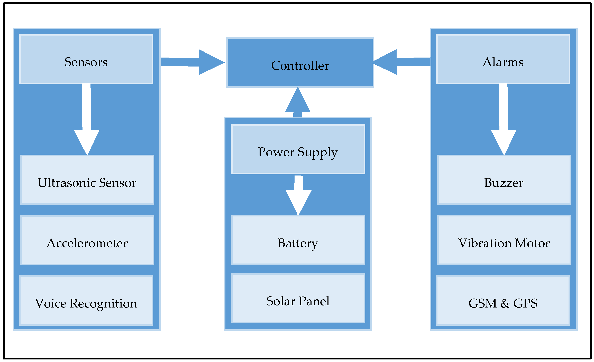
Fig 6.1. System Architecture

6.2 UML DIAGRAM
6.2.1 USE CASE DIAGRAM
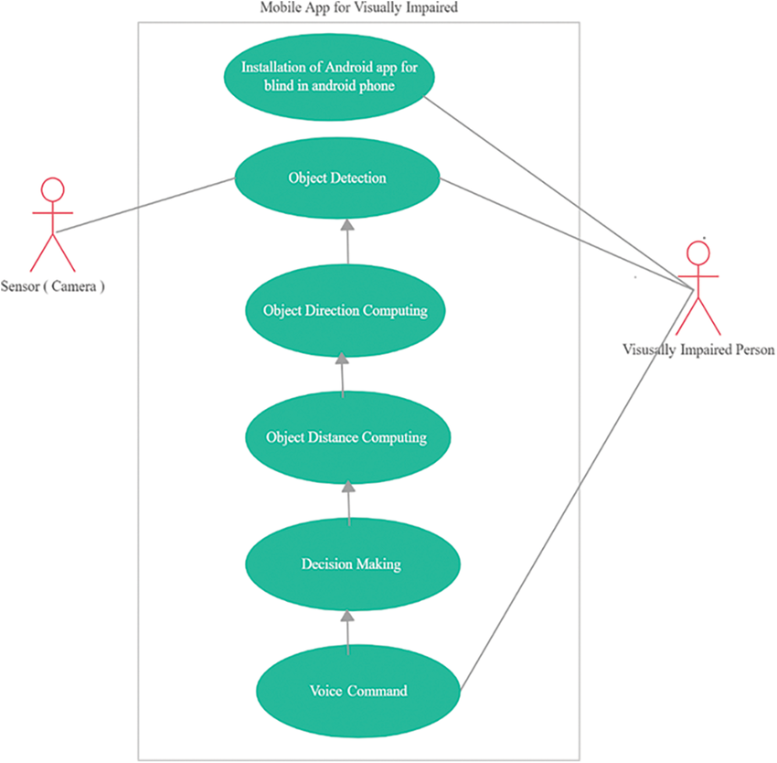

Fig 6.2.1 Use Case Diagram

6.2.2 SEQUENCE DIAGRAM

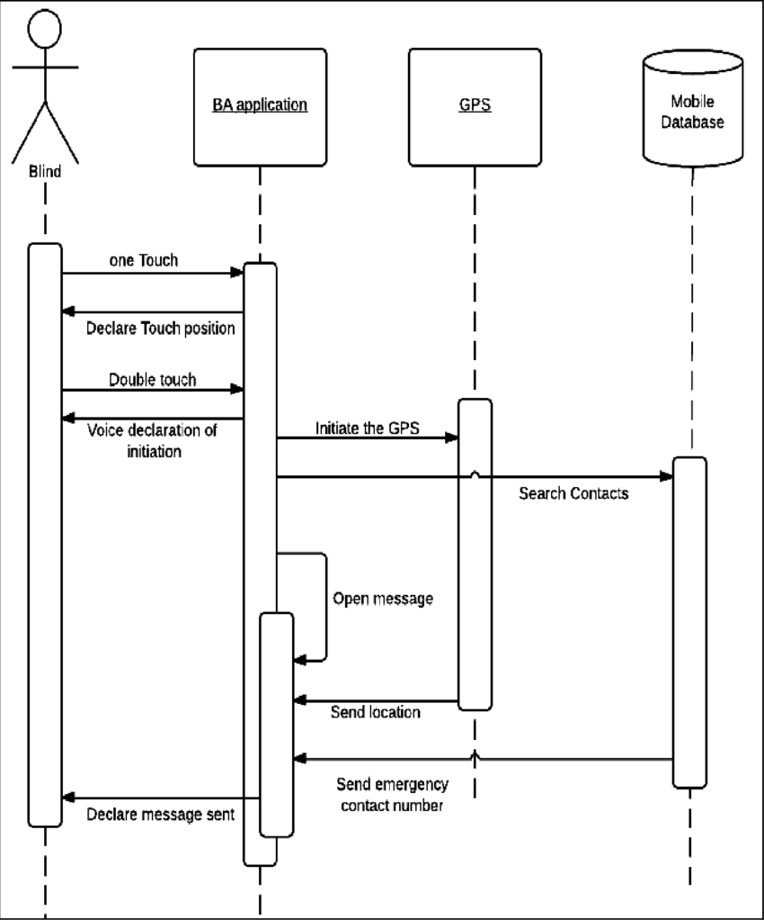

Fig 6.2.2 Sequence Diagram

6.3 ACTIVITY DIAGRAM

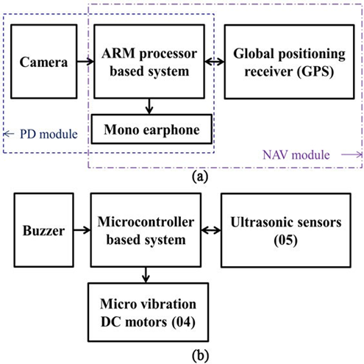
Fig 6.3 Activity Diagram

CHAPTER 7
HARDWARE DESCRIPTIONS
7.1 OVERVIEW
The Blind Assistance System (Path Saarathi) is a smart, integrated kit designed to enhance the mobility, navigation, and safety of visually impaired individuals. The system incorporates three essential modules Path Detection (PD), Depth Perception (DEP), and Navigation (NAV) which work in tandem to provide real-time assistance through audio cues and haptic feedback. This all-in-one system enables users to move through their environment with greater confidence, independence, and security. By combining cutting-edge technology with user-friendly interfaces, the Path Saarathi system offers a comprehensive solution for individuals with visual impairments, helping them navigate both familiar and new surroundings safely and efficiently.
The Path Detection (PD) module is the first line of defense, enabling the system to detect obstacles and identify safe paths. It uses a web camera paired with an ARM-based processor to capture and analyze the surrounding environment in real time. Through the use of advanced machine learning algorithms, the PD module can differentiate between obstacles and open paths, providing clear guidance to users. The system translates the data into audio cues delivered through a mono earphone, alerting the user to potential hazards or guiding them along a safe route. By constantly monitoring the environment and offering auditory feedback, the PD module ensures that users can navigate their surroundings without relying on traditional mobility aids like canes.
The Depth Perception (DEP) module enhances the system’s ability to detect obstacles at varying distances. This module consists of five ultrasonic sensors, four micro-vibration motors, and a buzzer, all working together to create a multi-layered feedback system. The ultrasonic sensors measure the distance between the user and nearby objects, while the micro-vibration motors provide haptic feedback through wrist vibrations. As the user approaches an obstacle, the intensity of the vibrations increases, alerting them to the proximity of potential hazards. The buzzer also emits sound alerts, offering an additional layer of feedback. This combination of haptic and auditory signals enables the user to respond to obstacles at different distances, making navigation safer and more intuitive.

The Navigation (NAV) module integrates advanced technologies like GPS and GIS to offer real-time location tracking and route planning. This module includes a GPS receiver, a GIS interface, a numeric keypad for input, and the Google Maps API, allowing the system to track the user’s current location and provide turn-by-turn navigation instructions. The system can also detect when the user deviates from their planned route and provides audio alerts to correct the course. This real-time navigation assistance is crucial for outdoor mobility, especially in unfamiliar areas. The NAV module empowers users to explore new locations with confidence, relying on clear spoken directions to guide them throughout their journey. The seamless integration of these features allows visually impaired individuals to travel independently while remaining aware of their surroundings.

Together, the Path Saarathi system’s integrated modules provide a comprehensive solution for visually impaired users, combining advanced sensors, machine learning, and real-time navigation technologies. By offering both haptic and audio feedback, the system ensures that users receive clear, actionable information in a way that is easy to understand and respond to. This innovative approach to assistive technology not only improves the safety and independence of visually impaired individuals but also enhances their ability to navigate through various environments whether on familiar streets or exploring new areas. With its intuitive design and powerful capabilities, Path Saarathi is a game-changing tool that promotes greater mobility, autonomy, and quality of life for users.

7.1.1 FEATURES
- Captures and analyses environmental visuals using a high-resolution web camera.
- Identifies obstacles based on contrast, Color, and depth perception.
- The camera is integrated into the for user convenience.
- Five ultrasonic sensors detect objects in multiple directions (front, left, right).
- Uses micro-vibration motors on the wrist to provide non-intrusive obstacle alerts.
- Alerts users about critical obstacles using two levels of beeping sounds.
- Efficiently manages sensor data and feedback cues.
- Detects floor-level, waist-level, and head-level obstacles for complete mobility assistance
- Provides real-time location updates.
7.1.2 COMPONENTS

The system comprises a range of integrated hardware components designed to assist visually impaired users in navigation and obstacle detection. A Web Camera (Logitech AC525) captures real-time images of the environment, which are processed by an ARM-Based Beagle Board-xM Processor running a machine learning model for path analysis. Audio feedback is delivered through a Mono Earphone, while a Battery Pack powers both the camera and the computing unit. Obstacle detection is achieved using Ultrasonic Sensors (Max Botix MB1340 & MB1330) that identify objects at varying heights and distances. To enhance spatial awareness, four Micro-Vibration DC Motors (M1, M2, M3, M4) provide haptic feedback, and a Buzzer emits audio alerts when obstacles are detected. An Atmega32 Microcontroller manages sensor data and feedback mechanisms. For navigation, the system includes a GPS Receiver (MT3329) for real-time location tracking, paired with a GIS Interface to support mapping functions. A Numeric Keypad enables users to input predefined destinations. Additionally, a Wireless Internet Dongle connects the device to the Google Maps API for real-time navigation support. A dedicated Battery Pack powers the GPS and navigation modules.

7.1.3 FUNCTIONS

Captures the surrounding environment and identifies walkable paths an obstacles using a machine learning model. Provides audio feedback for safe navigation. Uses ultrasonic sensors to detect obstacles in front, left, and right directions Sends haptic (vibration) and auditory (buzzer) alerts based on obstacle distance Tracks the user’s location using GPS. Provides voice-based navigation assistance via an earphone. Alerts users if they take the wrong path.

7.1.4 LIBRARIES
The Smart Kit System relies on various software libraries for image processing, machine learning, sensor control, and navigation. Below is a categorized list of the libraries used in the project:
- OpenCV
- Pillow (PIL)
- NumPy
- SciPy
- Scikit-learn
- TensorFlow/ Keras (Optional)
- Arduino Libraries
- AVR Libc
- Wire.h
- Serial Communication (pySerial)
- Ultrasonic.h
- PMW.h
- Google Maps API
- Geopy
- Dijkstra’s Algorithm
- GPS Module Library
- Pyttsx3
- gTTS

7.1.5 IoT & EMBEDDED SYSTEMS FRAMEWORKS
- Arduino Framework – Used for microcontrollers like ESP32, integrating touch, vibration, and ultrasonic sensors.
- MBED OS – A real-time operating system (RTOS) for ARM-based embedded systems.
- Zephyr OS – An open-source RTOS designed for kitand IoT applications.
- ESP-IDF (Espressif IoT Development Framework) – Ideal for ESP32-based smart Kit solutions.
- TensorFlow Lite – Optimized for on-device AI processing, useful for edge computing in wearables.
- OpenCV – Helps process camera input for obstacle detection and navigation.
- MediaPipe – Useful for hand gesture recognition or haptic feedback control.
- Edge Impulse – AI/ML platform tailored for embedded devices and wearables
- MQTT (Eclipse Paho, Mosquitto) – Lightweight messaging for IoT communication.
- Bluetooth Low Energy (BLE) Frameworks – Used for wireless communication with smartphones or external devices.
- AWS IoT Core / Google IoT Core – For cloud-based data processing, storage, and AI inferencing.
- Firebase – If the system requires cloud-based real-time data sync

7.2 ANDROID ARCHITECTURE

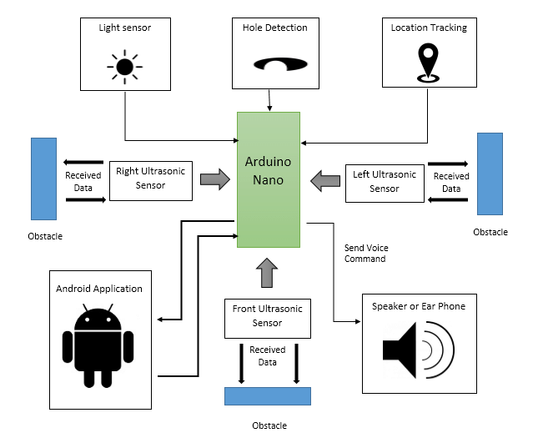
Fig 7.2 Android Architecture
7.2.1 ANATOMY
A Smart Kit system for visually impaired individuals consists of multiple interconnected components across several functional layers. The Hardware Layer includes the physical components embedded into the kit, such as the Microcontroller / Processing Unit (ESP32, Arduino, Raspberry Pi) that handles data collection and processing. The Haptic Feedback Module uses vibration motors to provide tactile feedback, while the Audio Module includes speakers or bone-conduction headphones for verbal alerts. The Battery & Power Management system ensures long-lasting operation, and Wireless Communication features like Bluetooth Low Energy (BLE), Wi-Fi, or NFC enable seamless connectivity with other devices. The Embedded Software Layer contains the firmware running on the microcontroller, which manages sensor data, processes inputs, and sends signals. It includes Sensor Data Processing to filter noise, detect obstacles, and analyze sensor inputs, as well as Haptic & Audio Feedback Control to generate alerts based on environmental data. Communication protocols like MQTT / WebSocket enable cloud connectivity, while BLE / Wi-Fi support communication with smartphones.
The Mobile Application serves as a control center for the user. It features a User Interface built using frameworks like Flutter, React Native, Android Jetpack, or SwiftUI to support cross-platform or native apps. It integrates Voice Assistants such as Google TTS, Amazon Polly, or IBM Watson for audio navigation. The app provides Real-time Notifications & Alerts such as obstacle warnings and battery level updates, along with Cloud Connectivity through services like AWS IoT or Firebase for remote monitoring. Users can access Customization Settings to adjust vibration intensity, choose alert types, and configure navigation preferences according to their needs. The Cloud & AI Processing Layer is essential for systems requiring advanced real-time processing. It includes Cloud Storage & IoT Management solutions like AWS IoT Core, Google Cloud IoT, or Firebase. This layer also supports AI & Computer Vision for features like object detection, face recognition, and scene analysis, as well as Navigation Assistance through GPS integration to support safe outdoor movement.
The Workflow of the Application follows a logical process to ensure user safety and system efficiency. First, sensors detect obstacles and transmit raw data to the microcontroller. The microcontroller processes this data, identifying the appropriate response, such as triggering a vibration or an audio alert. If necessary, the mobile app provides additional voice guidance or haptic feedback to support the user in real time. When cloud connectivity is enabled, the system uploads environmental data to the cloud for advanced analysis, enabling the AI models to learn and improve continuously. This comprehensive workflow ensures that the system is adaptive, intelligent, and responsive to the unique challenges faced by visually impaired individuals.

7.2.2 KEY TECHNOLOGIES USED
LAYER | TECHNOLOGIES & FRAMEWORKS
Hardware | ESP32, Raspberry Pi, Arduino, Sensors (Ultrasonic, IR, Camera, Pressure)
Embedded software | M bed OS, Zephyr, Arduino IDE, ESP-IDF
Communication | MQTT, BLE, Wi-Fi, NFC
AI/ML | TensorFlow Lite, OpenCV, Edge Impulse
Mobile App | Flutter, React Native, Android Jetpack, Swift UI
Cloud | AWS IoT, Google Firebase, Azure IoT Hub
7.2.3 INTERNET OF THINGS
The Internet of Things (IoT) refers to a vast and evolving network of interconnected devices that are capable of collecting, processing, and exchanging data over the internet. These devices span a wide range of applications, from smart home appliances like Alexa and smart lights to industrial sensors, medical equipment, and wearable gadgets. By embedding sensors and communication modules into everyday objects, IoT enables real-time monitoring, automation, and decision-making without direct human intervention.
The working of an IoT system involves multiple essential components. It starts with Sensors and Actuators, which collect real-world data such as temperature, motion, or heart rate. This data is then transmitted via various connectivity protocols like Wi-Fi, Bluetooth, Zigbee, or LoRa. Once transmitted, a Processing Unit, such as a microcontroller (e.g., Arduino, ESP32) or a more powerful microprocessor (e.g., Raspberry Pi), analyses the incoming data. Depending on the application, the data may be processed locally or sent onward for cloud-based analysis.
Cloud and Edge Computing play a significant role in managing large volumes of data generated by IoT devices. In cloud computing, data is sent to remote servers like AWS IoT or Google Cloud IoT, where it can be further processed, stored, and analysed at scale. Alternatively, edge computing allows data to be processed directly on the device or nearby local nodes, reducing latency and improving response times. Finally, the processed information is presented to users through a User Interface, which could be a mobile app, web dashboard, or voice assistant, enabling users to make informed decisions, monitor activity, or control connected devices seamlessly.
7.3 ARCHITECTURE OF JSP
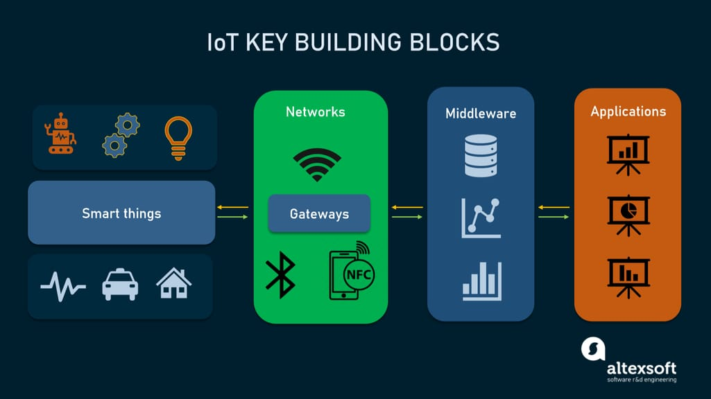
Fig 7.3 Architecture Of JSP
7.3.1 THE ADVANTAGES OF IoT
The Internet of Things (IoT) brings significant advantages by automating processes and increasing operational efficiency. For instance, smart thermostats automatically adjust temperatures based on user behaviour, eliminating the need for manual input. In industries, Industrial IoT (IIoT) enables real-time monitoring of equipment and production lines, helping businesses enhance productivity, reduce downtime, and optimize resource usage. These automated systems not only improve accuracy but also allow human workers to focus on more strategic tasks.
Another major benefit of IoT is cost savings through smart resource management and predictive maintenance. IoT-enabled systems can detect potential machine failures before they occur, helping companies avoid expensive repairs and reduce downtime. In agriculture, smart irrigation systems monitor soil moisture and environmental conditions, ensuring that water and fertilizers are used only when necessary. This precision agriculture approach reduces waste, saves money, and improves crop yields, making farming more sustainable and efficient.
IoT also enhances decision-making and quality of life. By offering real-time data analytics, IoT helps businesses fine-tune their strategies and respond quickly to market demands. In healthcare, IoT devices monitor patients remotely, alerting medical staff in emergencies and allowing for proactive care. On a personal level, IoT improves everyday life through smart homes equipped with voice-controlled appliances and advanced security systems.IoT devices like fitness trackers monitor health metrics such as heart rate and sleep patterns, encouraging healthier lifestyles. Moreover, scalability and connectivity are built into modern IoT ecosystems, with cloud computing, 5G, and edge computing ensuring fast, reliable communication between devices, making it easy to expand systems as needed.
7.3.2 ARDUINO
Arduino is an open-source electronics platform based on microcontrollers. It is widely used for IoT applications due to its simplicity and versatility.
- Arduino Uno – Best for beginners, based on ATmega328P.
- Arduino Mega – More pins and memory, ideal for complex projects.
- Arduino Nano – Compact, good for wearables and mini projects.
- Arduino MKR1000 / MKR WiFi 1010 – Built-in Wi-Fi for IoT applications.
- ESP32 (Arduino Compatible) – Wi-Fi & Bluetooth-enabled microcontroller for smart devices.
The working of an Internet of Things (IoT) system is a multi-stage process that integrates sensing, communication, processing, and actuation to deliver intelligent automation across various applications. At the core of any IoT system is the collection of data, which begins with the use of physical sensors. These sensors are responsible for monitoring and capturing real-world parameters such as temperature, humidity, light intensity, motion, pressure, gas concentration, proximity, or even biometric data. These values represent raw input from the environment and are critical for informing the system of current conditions. The type of sensor used depends on the specific requirements of the application. For instance, a smart home might use PIR (passive infrared) sensors for motion detection, while an industrial setting might rely on gas sensors or temperature sensors to monitor machinery and environmental safety.
Once the data is collected by the sensors, it is passed to a processing unit, which is typically a microcontroller or microprocessor. Common choices include Arduino, ESP32, Raspberry Pi, or more advanced embedded systems like ARM Cortex-based processors. These processing units are programmed using languages such as C, C++, Python, or MicroPython. The role of the processor is to analyze the incoming sensor data and make logical decisions based on pre-defined instructions or algorithms. This step might involve filtering noise from the data, applying thresholds, or running more complex machine learning models for pattern recognition. The decisions made in this stage determine the subsequent actions of the system.
After processing, the information often needs to be transmitted to other devices, systems, or cloud platforms for further analysis, storage, or remote control. This communication is facilitated using wireless technologies like Wi-Fi, Bluetooth, Zigbee, NB-IoT, or LoRa, depending on the desired range, data rate, and power consumption. Wi-Fi is typically used for short to medium-range applications requiring high data throughput, such as smart security cameras or home automation systems. Bluetooth is preferred for close-range, low-energy applications like fitness trackers or wearable devices. LoRa, on the other hand, is suitable for long-range communication with low data rates and is often used in agricultural monitoring or smart cities.
7.3.4 RUN-TIME ENVIRONMENT
A Run-Time Environment (RTE) is a crucial component in the execution of IoT applications, providing the necessary infrastructure to support code execution, manage memory, and handle process scheduling. It ensures that IoT devices operate efficiently by overseeing how software runs on the hardware. The RTE handles the underlying complexity of interacting with sensors, actuators, and communication protocols, enabling developers to focus on application logic rather than low-level hardware management.
There are two main types of RTEs used in IoT systems. The first is the Embedded Run-Time Environment (Bare Metal), which runs directly on microcontrollers like Arduino and ESP32 without the support of a traditional operating system. These systems use lightweight firmware written in C/C++ to interact with the hardware and perform specific tasks. The second type is the Real-Time Operating System (RTOS), which is used in more complex IoT devices such as Raspberry Pi or NVIDIA Jetson. These devices can run sophisticated applications and often use environments like Docker or Node.js runtimes for cloud-based IoT solutions, allowing for better task management, real-time responsiveness, and scalability in distributed networks.
7.3.5 IoT LIFE CYCLE
The IoT life cycle encompasses several key stages, beginning with Development and Prototyping. In this phase, developers select appropriate hardware platforms such as Arduino, ESP32, or Raspberry Pi, depending on the project’s complexity and resource requirements. Firmware is written using tools like the Arduino IDE, or programming languages such as Python and C++. Initial testing is conducted with sensors and actuators to ensure that the system performs as expected under controlled conditions before being scaled for real-world applications.
Next comes Deployment and Installation, where IoT devices are rolled out in targeted environments ranging from homes and industries to smart cities. During this phase, proper connectivity setup is crucial, utilizing technologies like Wi-Fi, LoRa, LTE, or 5G, depending on the data transmission range and speed needed. Once deployed, the devices begin the Data Collection and Processing stage, where sensors continuously monitor real-time parameters. This data can be processed locally through edge computing for faster responses or transmitted to cloud platforms for deeper analysis.
In the Data Transmission and Storage phase, communication protocols such as MQTT, HTTP, or CoAP are used to ensure efficient and secure transfer of data. The data is then stored in cloud databases like AWS IoT or Google Firebase, making it accessible for further analysis. The Analysis and Decision-Making stage leverages AI and machine learning techniques to identify trends, enable predictive maintenance, and support smart city applications. Results are presented through dashboards and mobile apps, allowing users and stakeholders to make informed decisions based on real-time insights.
The final phases involve Maintenance and Updates followed by Decommissioning and Recycling. Regular maintenance includes Over-the-Air (OTA) firmware updates and continuous remote diagnostics to monitor device health and performance. As devices reach the end of their operational life, they are either recycled or replaced. During decommissioning, proper data security measures such as data wiping or encryption are taken to protect sensitive information before disposal, ensuring compliance with privacy standards and environmental sustainability.

CHAPTER 8
TESTING

8.1 AIM OF TESTING
Testing is an activity to verify that a correct system is being built and is performed with the intent of finding faults in the system. However, testing is not restricted to being performed after the development phase is complete. But this is too carried out in parallel with all stages of system development, starting with requirements specification. Testing results, once gathered and evaluated, provide a qualitative indication of software quality and reliability and serve as a basis for design modification if require a project is said to be incomplete without proper testing.

8.2 TEST CASE
A test case is a set of conditions, inputs, actions, and expected outcomes used to determine whether a system or application functions correctly. It serves as a detailed scenario for validating specific features or functionalities. A well-written test case includes a unique identifier, test description, preconditions, test steps, expected results, and postconditions. It helps ensure software reliability, detects defects, and verifies compliance with requirements. Test cases can be manual or automated, depending on the testing approach. Effective test cases are clear, concise, and reusable, helping testers systematically evaluate software behaviour under various conditions to improve overall quality and performance.

8.3 TYPES OF TESTING
The various levels of testing are.
- White Box Testing
- Black Box Testing
- Unit Testing
- Functional Testing
- Performance Testing
- Integration Testing
- Integration Testing
- Validation Testing
- System Testing
- Structure Testing
- Output Testing
- User Acceptance Testing

8.3.1 WHITE BOX TESTING
White-box testing (also known as clear box testing, glass box testing, transparent box testing, and structural testing) is a method of testing software that tests internal structures or workings of an application, as opposed to its functionality (i.e., black-box testing).
While white-box testing can be applied at the unit, integration and system levels of the software testing process, it is usually done at the unit level. It can test paths within a unit, paths between units during integration, and between subsystems during a system–level test.
White-box test design techniques include:
- Control flow testing
- Data flow testing
- Branch testing
- Path testing
- Statement coverage
- Decision coverage
White-box testing is a method of testing the application at the level of the source code. The test cases are derived through the use of the design techniques mentioned above: control flow testing, data flow testing, branch testing, path testing, statement coverage and decision coverage as well as modified condition/decision coverage. These White-box testing techniques are the building blocks of white-box testing, whose essence is the careful testing of the application at the source code level to prevent any hidden errors later. These different techniques exercise every visible path of the source code to minimize errors and create an error-free environment.

White-box testing is a software testing technique that involves examining the internal structures or workings of an application, rather than just its functionality. It operates on various levels, starting with Unit Testing, where individual pieces of code are tested in isolation. During this phase, white-box testing ensures that each function or method works correctly according to its internal logic. This is achieved through detailed examination of the source code, enabling early detection of errors before integration with other components. Catching these bugs at this stage minimizes the chances of complications arising later during the development cycle.
The next level is Integration Testing, where the focus shifts to verifying the correctness of the interactions between different modules or components. While unit testing ensures that each piece functions independently, integration testing ensures that combined units behave as expected when working together. White-box testing here helps the programmer assess known interface interactions, validating the flow of data and control between integrated units. Additionally, Regression Testing involves reusing previously developed white-box test cases from the unit and integration phases to ensure that recent changes or additions to the codebase haven’t introduced new bugs or broken existing functionalities.
The white-box testing process follows a structured procedure. It starts with the Input phase, where necessary materials such as functional specifications, design documents, source code, and security requirements are gathered. This lays the groundwork for understanding what needs to be tested. In the Processing Unit phase, risk analysis is performed to guide the development of a comprehensive test plan, test cases are executed, and outcomes are carefully documented. Finally, in the Output phase, a detailed report is prepared that includes all preparations, test case results, and evaluations. This report serves as a final documentation of the effectiveness and completeness of the white-box testing process.

8.3.2 BLACK BOX TESTING
Black-box testing is a method of software testing that examines the functionality of an application (e.g., what the software does) without peering into its internal structures or workings (see white-box testing). This method of testing can be applied to virtually every level of software testing: unit, integration, system, and acceptance. It typically well. Comprises most if not all higher-level testing, but can also dominate unit testing as Black-box testing focuses on evaluating the functionality of an application without requiring any knowledge of its internal code or structure. In this type of testing, the tester does not need to have programming skills or access to the source code. Instead, they are only concerned with what the software is supposed to do, not how it achieves that functionality. This approach allows testers to simulate user behavior and validate whether the application meets its intended requirements based on observable outputs.
Test cases in black-box testing are designed around the software’s specifications and requirements. These cases are built using external documentation such as user requirements, functional specifications, and design parameters. The goal is to ensure that the application behaves correctly for both expected and unexpected inputs. Since the tester does not look into the internal code logic, black-box test cases are ideal for checking system behavior, user interfaces, and integration with external systems.
To effectively design test cases in black-box testing, several established test design techniques are commonly used. These include decision table testing, which helps in understanding different combinations of inputs and their corresponding outcomes; all-pairs testing, which reduces the number of test cases by ensuring that all possible pairs of input values are tested; and state transition tables, which are useful for testing systems that respond differently based on their current state. Additionally, equivalence partitioning divides input data into valid and invalid partitions to reduce test coverage while ensuring effectiveness, and boundary value analysis focuses on values at the edges of input ranges, where errors are most likely to occur.

8.3.3 UNIT TESTING
In computer programming, unit testing is a method by which individual units of source code, sets of one or more computer program modules together with associated control data, usage procedures, and operating procedures are tested to determine if they are fit for use. Intuitively, one can view a unit as the smallest testable part of an application. In procedural programming, a unit could be an entire module, but is more commonly an individual function or procedure. In object-oriented programming, a unit is often an entire interface, such as a class, but could be an individual method. Unit tests are created by programmers or occasionally by white box testers during the development process.
Software testing is a combinatorial problem. For example, every Boolean decision statement requires at least two tests: one with an outcome of "true" and one with an outcome of "false". As a result, for every line of code written, programmers often need 3 to 5 lines of test code.
Unit testing embedded system software presents a unique challenge: Since the software is being developed on a different platform than the one it will eventually run on, you cannot readily run a test program in the actual deployment environment, as is possible with desktop programs.

8.3.4 FUNCTIONAL TESTING
Functional testing is a quality assurance (QA) process and a type of black box testing that bases its test cases on the specifications of the software component under test. Functions are tested by feeding them input and examining the output, and internal program structure is rarely considered (not like in white-box testing). Functional Testing usually describes what the system does.
Functional testing typically involves five steps. The identification of functions that the software is expected to perform.
- The creation of input data based on the function's specifications.
- The determination of output is based on the function's specifications.
- The execution of the test case
- The comparison of actual and expected outputs.

8.3.5 PERFORMANCE TESTING
In software engineering, performance testing is in general testing performed to determine how a system performs in terms of responsiveness and stability under a particular workload. It can also serve to investigate, measure, validate or verify other quality attributes of the system, such as scalability, reliability and resource usage.
Load testing is a fundamental type of performance testing that evaluates how a system behaves under a specific, expected load. This involves simulating a particular number of concurrent users performing transactions over a defined period. The goal is to ensure that the system can handle the anticipated user activity without degradation in performance. By observing response times, throughput, and resource utilization, developers and testers can determine whether the application will function properly under normal usage conditions.
Stress testing, on the other hand, is designed to determine the system’s breaking point by pushing it beyond its expected load limits. This type of testing helps assess how the system performs under extreme conditions and whether it can recover gracefully from failure. It is particularly useful in identifying potential vulnerabilities, such as memory leaks or buffer overflows, which may not be apparent under normal usage. Stress testing ensures the application remains robust even when user demand spikes unexpectedly.
Soak testing, also referred to as endurance testing, focuses on evaluating a system’s stability and performance over an extended period under a consistent expected load. The primary objective is to detect issues like memory degradation, performance dips, or resource leaks that might occur only after prolonged use. This type of testing is crucial for applications expected to run continuously for long durations, ensuring they can maintain reliability without failure over time.
Configuration testing and isolation testing serve different but important roles in system evaluation. Configuration testing examines how changes in system setup—such as altering server settings, load-balancing techniques, or database configurations—affect overall performance and behaviour. It helps in optimizing the system by identifying the best possible configurations. Meanwhile, isolation testing is used to replicate and analyze issues that surfaced during earlier tests.

8.3.6 INTEGRATION TESTING
Integration testing (sometimes called integration and testing, abbreviated I&T) is the phase in software testing in which individual software modules are combined and tested as a group. It occurs after unit testing and before validation testing. The purpose of integration testing is to verify functional, performance, and reliability requirements placed on major design items. These "design items", i.e. assemblages (or groups of units), are exercised through their interfaces using black box testing, success and error cases being simulated via appropriate parameter and data inputs. Simulated usage of shared data areas and inter-process communication is tested and individual subsystems are exercised through their input interface.
Test cases are constructed to test whether all the components within assemblages interact correctly, for example across procedure calls or process activations, and this is done after testing individual modules, i.e. unit testing. The overall idea is a "building block" approach, in which verified assemblages are added to a verified base which is then used to support the integration testing of further assemblages. Some different types of integration testing are big bang, top-down, and bottom-up. Other Integration Patterns are Collaboration Integration, Backbone Integration, Layer Integration, Client/Server Integration, Distributed Services Integration and High-frequency Integration.
In the Big Bang approach, all or most of the developed modules are coupled together to form a complete software system or major part of the system and then used for integration testing. The Big Bang method is very effective for saving time in the integration testing process. However, if the test cases and their results are not recorded properly, the entire integration process will be more complicated and may prevent the testing team from achieving the goal of integration testing. For integration testing, Usage Model testing can be more efficient and provides better test coverage than traditional focused functional integration testing. To be more efficient and accurate, care must be used in defining the user-like workloads for creating realistic scenarios in exercising the environment. This gives confidence that the integrated environment will work as expected for the target customers.
Bottom-Up Testing is an approach to integrated testing where the lowest level components are tested first, then used to facilitate the testing of higher-level components. The process is repeated until the component at the top of the hierarchy is tested. This approach is helpful only when all or most of the modules of the same development level are ready. This method also helps to determine the levels of software developed and makes it easier to report testing progress in the form of a percentage. Top-Down Testing is an approach to integrated testing where the top integrated modules are tested and the branch of the module is tested step by step until the end of the related module. Sandwich Testing is an approach to combine top-down testing with bottom up testing. The main advantage of the Bottom-Up approach is that bugs are more easily found. With Top Down, it is easier to find a missing branch link
8.3.7 VERIFICATION AND VALIDATION
The PMBOK Guide, as per its 4th edition and IEEE standards, defines validation as the assurance that a product, service, or system meets the needs of customers and other identified stakeholders. It is primarily focused on ensuring the final output is acceptable, suitable, and fit for purpose from the end-user's perspective. Validation typically involves testing and assessments that include the participation of external customers to confirm whether the developed solution fulfills the intended use or business need. This makes validation an external process, concentrating on the correctness and usefulness of the final deliverable.
In contrast, verification is defined as the evaluation of whether or not a product, service, or system complies with regulations, specifications, or conditions imposed during the development process. This is an internal process that ensures the product is built correctly, following the established design and technical requirements. Verification is often carried out through reviews, inspections, walkthroughs, and technical testing of components or subsystems. It focuses on the question: "Are we building the product right?”
During the development phase, verification procedures may involve performing specific tests that model or simulate parts or the whole of a product, followed by a detailed analysis of the results. These procedures aim to ensure that the system or component functions as designed. This process is essential for catching early-stage issues related to design flaws or compliance failures before they reach the customer.
On the other hand, validation confirms whether the development and verification processes have led to a solution that actually meets the initial business or stakeholder requirements. It provides evidence of fitness for purpose, often involving the end-users and stakeholders in acceptance testing. Importantly, a system can pass verification meaning it was built according to specification but still fail validation if those specifications were incomplete or failed to capture what the customer truly needed. This highlights the critical role of validation in confirming that the right problem has been solved with the right solution.

8.3.8 SYSTEM TESTING
System testing of software or hardware is testing conducted on a complete, integrated system to evaluate the system's compliance with its specified requirements. System testing falls within the scope of black box testing, and as such, should require no knowledge of the inner design of the code or logic.
As a rule, system testing takes, as its input, all of the "integrated" software components that have passed integration testing and also the software system itself integrated with any applicable hardware system(s). System testing is a more limited type of testing; it seeks to detect defects both within the "inter-assemblages" and also within the system as a whole.

8.3.9 STRUCTURE TESTING
It is concerned with exercising the internal logic of a program and traversing particular execution paths.

8.3.10 OUTPUT TESTING
The output of test cases is compared with the expected results that were defined during the test case design phase. This comparison helps ensure that the system behaves as intended and produces the correct results under given conditions. To further validate the accuracy of the output, testers often involve users by asking for their preferences regarding the output format, ensuring that what the system displays or prints aligns with user expectations and requirements. This step helps confirm both the functional correctness and the usability of the system’s output.
In this context, the output format is evaluated in two forms: on-screen display and printed output. The on-screen output is considered correct when it matches the design created during the system design phase, which was based on user input and specifications. Similarly, the printed output (hard copy) is validated to ensure it adheres to the format and content expected by the user. When both output types match the predefined requirements, it confirms that the system delivers the information accurately and in a user-friendly format.

8.3.11 USER ACCEPTANCE TESTING
Final Stage, before handling over to the customer which is usually carried out by the customer where the test cases are executed with actual data.
The system under consideration is tested for user acceptance and constantly keeping touch with the prospective system user at the time of developing and making changes whenever required.
It involves planning and execution of various types of test in order to demonstrate that the implemented software system satisfies the requirements stated in the requirement document.

CHAPTER 9
CONCLUSION AND FUTURE ENHANCEMENT

9.1 CONCLUSION
The paper summarizes the current issues in blind people life. To overcome from this. The Blind Assistance System, designed as a smart Kit solution, significantly enhances the mobility of visually impaired individuals by integrating ultrasonic sensors, a camera, and GPS. Through functional and usability evaluations, the system demonstrated improved obstacle detection and navigation assistance. It reduced cognitive and perceptual efforts for users, with 80% acknowledging its effectiveness. While the system effectively aids navigation, further enhancements in deep learning models, global navigation features, and hardware miniaturization are needed to optimize portability and accuracy for real-world applications.

9.2 FUTURE ENHANCEMENT
The future enhancements for the Blind Assistance System focus on improving its functionality, user experience, and technological advancements. The system can be enhanced by incorporating AI-driven deep learning models for more accurate obstacle detection and path navigation. Future versions could integrate LiDAR sensors for better depth perception and object recognition, improving navigation in crowded and dynamic environments. Miniaturizing hardware components will make the kit device more lightweight and comfortable. Additionally, incorporating real-time cloud-based data processing could improve GPS accuracy and provide real-time assistance. Enhancing voice commands and integrating with smart assistants like Alexa or Google Assistant would make the system more interactive. Improving battery efficiency and wireless connectivity for remote monitoring will further enhance usability. Future iterations can also include augmented reality (AR) for improved spatial awareness. Expanding real-world testing with a larger sample size will provide valuable feedback for refining system efficiency and ensuring accessibility in diverse environments.

APPENDIX-I
SAMPLE CODE

import cv2
import numpy as np
import pyttsx3
import serial

# Serial communication
ser = serial.Serial('COM4', baudrate=9600, timeout=1)

# YOLO file paths
YOLO_CONFIG_PATH = "yolov3.cfg"
YOLO_WEIGHTS_PATH = "yolov3.weights"
COCO_NAMES_PATH = "coco.names"

# Labels to announce
detect_labels = ['person', 'chair', 'car', 'dog', 'bicycle']

# Load class labels
try:
with open(COCO_NAMES_PATH, "r") as f:
LABELS = f.read().strip().split("\n")
except FileNotFoundError:
print("❌ Error: COCO names file not found.")
exit()

# Load YOLO model
net = cv2.dnn.readNetFromDarknet(YOLO_CONFIG_PATH, YOLO_WEIGHTS_PATH)
net.setPreferableBackend(cv2.dnn.DNN_BACKEND_CUDA)
net.setPreferableTarget(cv2.dnn.DNN_TARGET_CUDA)

# Get output layer names
layer_names = net.getLayerNames()
output_layers = [layer_names[i - 1] for i in net.getUnconnectedOutLayers().flatten()]

# Text-to-speech engine
engine = pyttsx3.init()
engine.setProperty("rate", 150)

# Object detection function
def detect_objects(frame):
(H, W) = frame.shape[:2]
blob = cv2.dnn.blobFromImage(frame, 1/255.0, (416, 416), swapRB=True, crop=False)
net.setInput(blob)
layer_outputs = net.forward(output_layers)

boxes, confidences, class_ids = [], [], []

for output in layer_outputs:
for detection in output:
scores = detection[5:]
class_id = np.argmax(scores)
confidence = scores[class_id]

if confidence > 0.5:
box = detection[0:4] * np.array([W, H, W, H])
(centerX, centerY, width, height) = box.astype("int")
x = int(centerX - width / 2)
y = int(centerY - height / 2)

boxes.append([x, y, int(width), int(height)])
confidences.append(float(confidence))
class_ids.append(class_id)

idxs = cv2.dnn.NMSBoxes(boxes, confidences, 0.4, 0.3)

detected_objects = []
if len(idxs) > 0:
for i in idxs.flatten():
label = LABELS[class_ids[i]]
if label in detect_labels:
detected_objects.append(label)
x, y, w, h = boxes[i]
cv2.rectangle(frame, (x, y), (x + w, y + h), (0, 255, 0), 2)
cv2.putText(frame, label, (x, y - 10), cv2.FONT_HERSHEY_SIMPLEX, 0.6, (0, 255, 0), 2)

return frame, list(set(detected_objects)) # Unique objects only

def speak_and_send(objects):
if not objects:
return

msg = "Detected: " + ", ".join(objects)
print("🗣️", msg)
engine.say(msg)
engine.runAndWait()

for obj in objects:
if obj == "person":
ser.write(b'A')
elif obj == "chair":
ser.write(b'B')
elif obj == "car":
ser.write(b'c')
elif obj == "dog":
ser.write(b'D')
elif obj == "bicycle":
ser.write(b'E')

# Main loop
def main():
cap = cv2.VideoCapture(0)

if not cap.isOpened():
print("❌ Camera not accessible.")
return

print("🎥 Real-time detection started. Press 'q' to quit.")

frame_count = 0
while True:
ret, frame = cap.read()
if not ret:
break

frame_count += 1
detected_frame, detected_objects = detect_objects(frame)

if frame_count % 30 == 0 and detected_objects: # Speak every 30 frames (~1 sec)
speak_and_send(detected_objects)

cv2.imshow("YOLO Real-Time Detection", detected_frame)

if cv2.waitKey(1) & 0xFF == ord('q'):
break

cap.release()
cv2.destroyAllWindows()

if __name__ == "__main__":
main()

APPENDIX-II
SCREENSHOTS

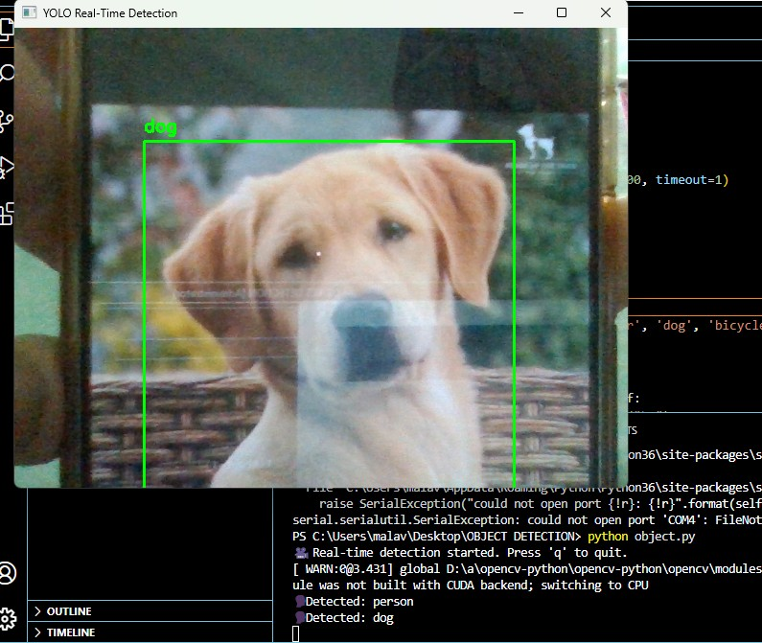

The image shows a real-time object detection interface using YOLO (You Only Look Once), identifying objects through a webcam. A golden-colored dog is prominently visible at the center, enclosed in a green bounding box labeled “dog.” A second green bounding box, partially overlapping the dog, is labeled “person,” indicating dual detections. The right portion of the image displays the Python terminal output, confirming detection of a "dog" and "person." A warning indicates that CUDA is not available, so processing is done on the CPU.

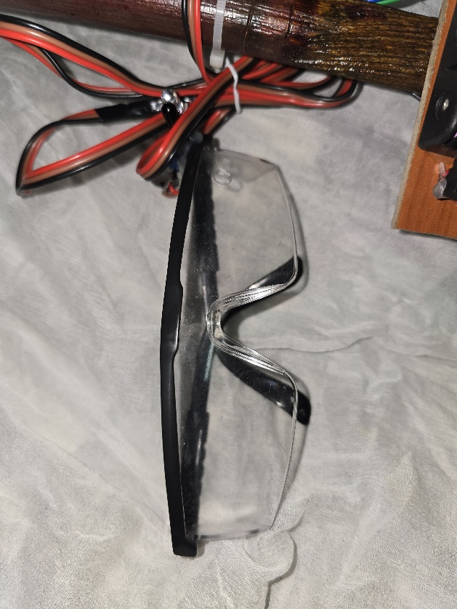

The image shows a pair of safety glasses with clear plastic lenses and a black frame, placed beneath a wooden rod or support structure. Several red and black electrical wires are wrapped and secured around the wooden rod using zip ties, suggesting the setup is part of an electronic or wearable device prototype. The wooden component is attached to a small wooden board with screws, possibly housing a sensor or electronic component. The setup appears to be related to a DIY or assistive technology project, potentially for visually impaired users, combining protective eyewear with embedded wiring for sensors or feedback systems.

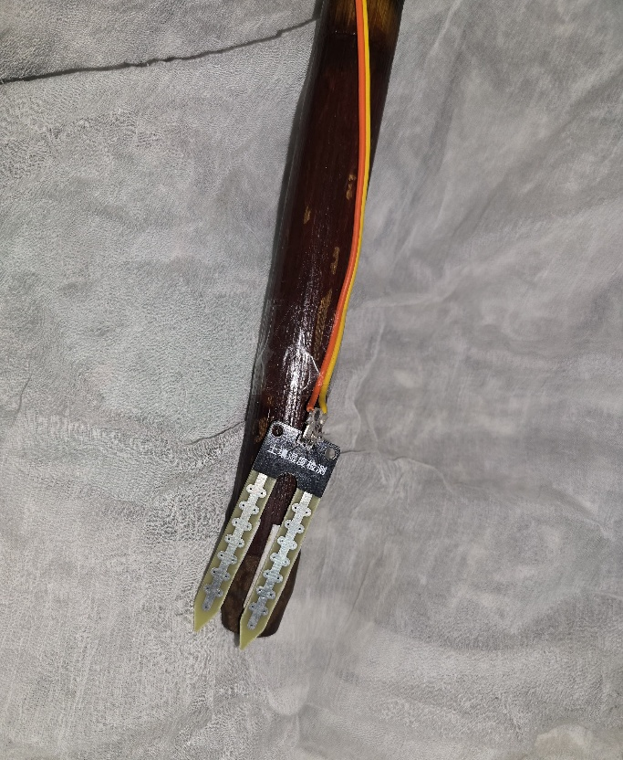

The image shows a soil moisture sensor module attached to a wooden stick, secured with tape. The sensor features two metallic prongs with multiple contact points used to measure moisture levels in the soil. It is connected by three colored wires (yellow, red, and black) that likely transmit power and data signals to a microcontroller. The sensor has Chinese text printed on the black plastic module at the top. This setup appears to be part of a DIY or educational electronics project, possibly for environmental sensing, agricultural monitoring, or as a prototype in a smart cane or assistive technology system.

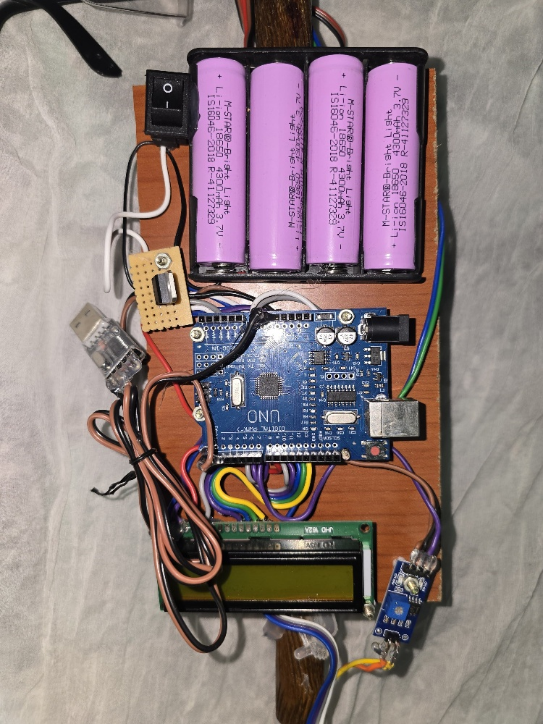

This image shows a custom-built electronics module mounted on a wooden board. The main component is an Arduino Uno microcontroller, centrally placed and connected to various modules via colorful jumper wires. At the top, four pink 3.7V lithium-ion batteries are secured in a black holder, providing power to the system. A switch is located beside the batteries for power control. Below the Arduino is an LCD display module (likely 16x2) for data output. Additional components include a USB interface, a small breadboard with a button, and a sensor module. This setup appears to be part of a DIY electronics or assistive technology project.

REFERENCES
- Bhatlawande, S., Borse, R., Solanke, A., & Shilaskar, S. (2024). A Smart Kit Approach for Augmenting Mobility of Visually Impaired People. IEEE Access, 12, 24659-24671. DOI: 10.1109/ACCESS.2024.3364915.
- World Health Organization (WHO). (2023). World Report on Vision. Retrieved from https://www.who.int/publications/i/item/9789241516570.
- Giudice, N. A., & Legge, G. E. (2008). Blind navigation and the role of technology. In The Engineering Handbook of Smart Technology for Aging, Disability, and Independence (pp. 479–500). Wiley.
- Madake, J., Bhatlawande, S., Solanke, A., & Shilaskar, S. (2023). A qualitative and quantitative analysis of research in mobility technologies for visually impaired people. IEEE Access, 11, 82496–82520.
- Ashiq, F., Asif, M., Ahmad, M. B., Zafar, S., Masood, K., Mahmood, T., & Lee, I. H. (2022). CNN-based object recognition and tracking system to assist visually impaired people. IEEE Access, 10, 14819–14834.
- Villanueva, J., & Farcy, R. (2012). Optical device indicating a safe free path to blind people. IEEE Transactions on Instrumentation and Measurement, 61(1), 170–177.
- Nada, A. A., Fakhr, M. A., & Seddik, A. F. (2015). Assistive infrared sensor-based smart stick for blind people. Proceedings of the Scientific Information Conference (SAI), 1149–1154.
- Busaeed, S., Katib, I., Albeshri, A., Corchado, J. M., Yigitcanlar, T., & Mehmood, R. (2022). LidSonic V2.0: A LiDAR and deep-learning-based green assistive edge device to enhance mobility for the visually impaired. Sensors, 22(19), 7435.
- Brilhault, A., Kammoun, S., Gutierrez, O., Truillet, P., & Jouffrais, C. (2011). Fusion of artificial vision and GPS to improve blind pedestrian positioning. Proceedings of the 4th IFIP International Conference on New Technologies, Mobility, and Security, 1–5.
- Son, H., Krishnagiri, D., Jeganathan, V. S., & Weiland, J. D. (2020). Crosswalk Guidance System for the Blind. In Proceedings of the IEEE Engineering in Medicine and Biology Society (EMBC) (pp. 3327–3330).
[11] Shangguan, L., Liu, Z., Li, M., & Zhao, D. (2014). CrossNavi: Enabling Real-Time Crossroad Navigation for the Blind with Commodity Phones. In Proceedings of the 2014 ACM International Joint Conference on Pervasive and Ubiquitous Computing (pp. 787–798). ACM. DOI: 10.1145/2632048.2632067.
[12] Li, X., Lin, Z., Cao, K., Zhang, Y., Wu, Y., & Li, K. (2019). Cross-Safe: A Computer Vision-Based Approach to Make All Intersection-Related Pedestrian Signals Accessible for the Visually Impaired. In Proceedings of the Science and Information Conference (pp. 161–173). Springer, Cham. DOI: 10.1007/978-3-030-25629-6_12.
[13] Viola, P., & Jones, M. (2001). Rapid Object Detection Using a Boosted Cascade of Simple Features. In Proceedings of the 2001 IEEE Computer Society Conference on Computer Vision and Pattern Recognition (Vol. 1, pp. I-511–I-518). IEEE. DOI: 10.1109/CVPR.2001.990517.
[14] Ahonen, T., Hadid, A., & Pietikainen, M. (2006). Face Description with Local Binary Patterns: Application to Face Recognition. IEEE Transactions on Pattern Analysis and Machine Intelligence, 28(12), 2037–2041. DOI: 10.1109/TPAMI.2006.244.
[15] Simonyan, K., & Zisserman, A. (2014). Very Deep Convolutional Networks for Large-Scale Image Recognition. arXiv preprint arXiv:1409.1556. Retrieved from https://arxiv.org/abs/1409.1556.

THANK YOU

